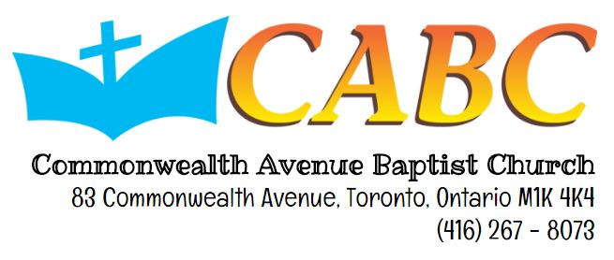
YPM Urban Street Mission
June 18, 2016 (Saturday) from 9:30am to 3:00pm

Dear Parents,

Please be advised that Urban Street Mission [USM] is this Saturday, June 18, 2016 – from 9:30AM to 3:00PM. To register for the event, kindly fill up the consent form below and submit it the respective leaders by the said date. Only those with permission forms will be allowed to go.

- We will be meeting in CABC at 9:30AM and we will go together to downtown as a group
- Transportation (tickets/tokens) will be provided for the participants
- Lunch will be provided
- The youth will be going back to church after the activity and parents can pick them up at 3:00PM in CABC

What is USM?
Urban Street Mission (USM) is an outreach activity that opens new opportunity for the young people to be involved in serving the community. During the USM, the YPM will go to downtown to share the love of Christ to the homeless through giving out sandwiches or gift cards. Our prayer is that this opportunity in ministering through distributing lunches or gift cards would open a door for us to share with them the hope we have in Christ through our salvation. Also, we hope that this opportunity will become a training ground for all the young people in the YPM.

We hope that your youth can join us for the Urban Street Mission activity. If you have any questions of concerns regarding this event, please contact Pastor Alex or Jorel Gatuz.
YPM e-mail: cabc.ypm@gmail.com

You may keep this part for your reference
Please tear this part and return it to the respective YPM leaders --- RETURN THIS SLIP BY JUNE 18, 2016

Name of Youth: __________________________________________________  E-mail: ___________________________________________________________ |  | Phone Number: ____________________________  Grade: _____________________ Age: ___________
In case of any emergency, please contact:
Contact Person: __________________________________________________  Relationship with youth: ________________________________________ |  | Phone Number: ____________________________
 | CONSENT FORM
I, ______________________________________________, give permission for my child, _______________________________________________, to join the Urban Street Mission (USM) at Downtown in Toronto Ontario on June 18, 2016. I am aware of the activities my child is participating in and I acknowledge that all volunteers will do their best in keeping my child safe given that he/she adheres to the rules set for the above-mentioned activity. I trust that all the volunteers and leaders will make the appropriate decisions regarding my child’s wellness in the event of an emergency. By signing below, I release all liability from the leaders, volunteers and the church – Commonwealth Avenue Baptist Church.

If you agree with the statement above, please print your name, date and sign below.

_____________________________________________________________ ______________________________________ ____________________________________________
Name of Parent/Guardian Date Signature
*If signed by guardian, must be 18+ years old

